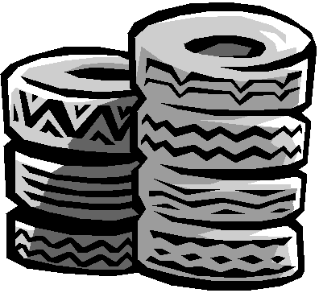
TIRE DISPOSAL

FREE
June 10 – 20, 2022
Hours are Monday – Saturday: 8 AM – 6 PM
Sunday: 1 PM – 5 PM

Dodge County Transfer Station (old Landfill)
Off Dodge Avenue in Eastman

Bring your unwanted tires to the Transfer Station where someone will be standing by to unload them for you.
No limit to how many you bring!

Dodge County Residents or Land Owners Only
(Excludes: tires with rims, tractor tires over 4 ½ feet high, tires from businesses involving tires, shredded tire material)
For more information, contact Sharon Cobb Flanagan (619-322-4505), Conner Bearden (478-374-4361), Alan Mills (478-231-2749), Facebook Litter-Free Dodge

Litter-Free
Dodge

