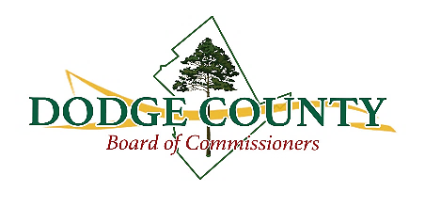
Dodge County Road Committee Meeting Minutes
Wednesday, July 02, 2025 at 10:30 a.m.

Commissioners Present: Sharon Cobb Flanagan - District 1, Leigh Ann Greene - District 2
Also Present: Manager Conner Bearden, Clerk Kimberly Smith-Parkerson

Call to Order
County Manager Bearden called the meeting to order at 10:30 a.m.

Review of Minutes
- April 09, 2025
The minutes from April 09, 2025, were reviewed. No revisions were suggested.

Old Business
- Department Training
County Manager discussed heavy operator equipment training with Oconee Fall Line Technical College representative. He learned the Fitzgerald Campus, Wiregrass Georgia Technical College, has a program with simulators that may be adequate. He’s awaiting more information.

New Business
- 2025 Local Road Assistance Administration (LRA)
Bids packets are due July 10 at 2 p.m. At the next commissioner meeting, there will be a budget amendment to add the LRA funds to the budget in the amount of $1,189,089. (There’s no match required on the LRA funds.)
- 2026 Local Maintenance and Improvement Grant (LMIG)
2026 LMIG will be in the amount of $1,098,334.18 with a match of 10%. The following roads were discussed for the 2026 LMIG project: Powers Road, Albert Lampkin Road, Bedsole Road, Tangerine Road, Orange Lane, Garrett Oxley Road, Bill Hambrick Road, Sparrow Lane, Fish Road, and Nicholson Carr Road.
- 2025 GTIB Application
County Manager Bearden stated the GTIB notified $2 million was awarded in grant money and $2.4 million was available for loan. The projects assessed for the application were Bill Mullis Road, Eastman Milan Road, and Zion Hill Road.
- County Road Network
Manager Bearden updated the committee on WPA Road’s repair and FEMA’s requirements for funding.

Adjourn
The meeting adjourned at 10:42 a.m.

Attested: Approved:

_______________________________________ ________________________________________
Kimberly Smith-Parkerson, County Clerk Conner Bearden, County Manager

